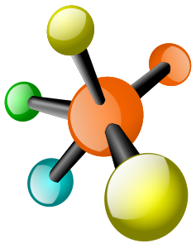
Name: Per:

Biology EOC WebQuest Study Guide

BIOLOGY & THE CHARACTERISTICS OF LIFE
Use the link to watch the “What Is Biology? The Characteristics of Life” video by The Science Classroom. As you watch, take notes in the table below. http://tinyurl.com/zneosgz OR https://www.youtube.com/watch?v=7nKKoxnmTEA

Characteristics of Life | Notes From Video
1. Cells
2. DNA
3. Energy
4. Homeostasis
5. Reproduction
6. Evolution

HYPOTHESES, THEORIES, and LAWS
Use the link below to watch the “Fact V. Hypothesis V. Theory V. Law” video from It’s Okay To Be Smart. After you watch the video, decide if the following statements are True or False. If they are false, replace the underlined term in the statement with a new term that would make the statement true. Write that word on the line next to the statement.
http://tinyurl.com/j4vvfdc OR https://www.youtube.com/watch?v=lqk3TKuGNBA

7. Hypotheses are observations about the world around us. 7.

8. A hypothesis is a proposed explanation for a phenomenon made as a starting point for further investigation. 8.

9. A law is a scientific explanation developed through the scientific method through repeated testing, observation, and experimentation. 9.

10. In science, a theory is a detailed description usually using math to explain how something happens.
10.
SCIENTIFIC METHOD
Use the link below to play the “Inky the Squid and the Scientific Method” game from the Bioman Biology website. Choose Baby Squid Infinite Lives Level to complete all levels of the game. When you have completed the game, write down three facts you reviewed and your final score in the space below. http://tinyurl.com/gpomop7 OR https://www.biomanbio.com/HTML5GamesandLabs/SciMethodGames/inkysmhtml5page.html

11. Fact #1:

12. Fact #2:

13. Fact #3:

14. Your Score (bottom left corner of game screen):

PROPERTIES OF WATER
Use the link below to watch “How Polarity Makes Water Behave Strangely” by TedEd. As you watch the video, take notes in the table below about each property of water.
http://tinyurl.com/h3ctfmb OR https://www.youtube.com/watch?v=ASLUY2U1M-8

Property of Water | Description Of This Property of Water
15. Polarity
16. Hydrogen Bonding
17. Surface Tension
18. Cohesion
19. Adhesion
20. Density

MACROMOLECULES / BIOMOLECULES / ORGANIC MOLECULES
Use the link to complete the “Molecules of Life” Tutorial. As you complete the tutorial, answer the following questions.
http://tinyurl.com/zvla6qb OR http://www.cpalms.org/Public/PreviewResourceStudentTutorial/Preview/111955
Opening Slide Tab
21. What are the four predominant elements in biology?

Molecules Tab
22. What are the building blocks of macromolecules?
23. When monomers are linked together, the resulting molecule is called a
24. A monomer is a single . A polymer is a link of
In biological systems a polymer is called a
25. A train car is to a train, as a is to a polymer an a molecule is to a

Carbohydrates Tab
26. What are two important functions of carbohydrates?
27. What type of complex carbohydrate is cellulose and what is its role in plant cells?

Lipids Tab
28. What are three functions of lipids:

Proteins Tab
29. What are proteins made from? What cell organelle makes proteins?
30. Enzymes are an example of proteins. List some other types of proteins:

Nucleic Acids Tab
31. What are the main functions of nucleic acids?
32. How many strands make up RNA? How many strands make up DNA?
33. What are the three types of RNA?
34. What process do RNA molecules play a role in?
35. During the Nucleic Acid Practice, write the statement that refer to nucleic acids in the space below.
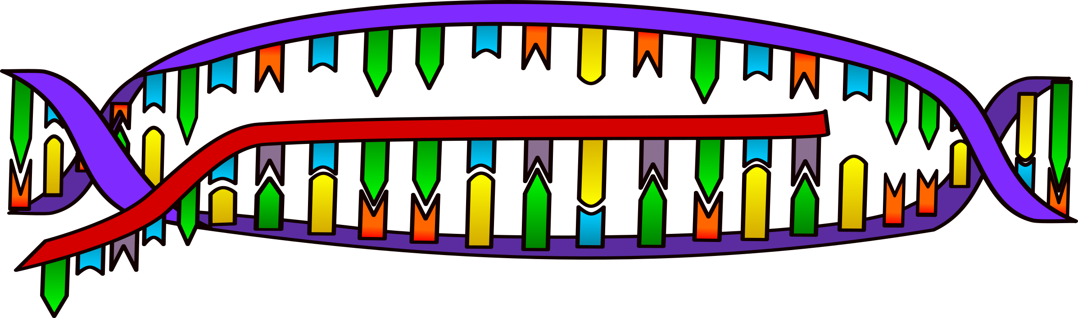
a)
b)
c)
d)

EUKARYOTIC AND PROKARYOTIC CELLS
Use the link below to watch the “Prokaryotes and Eukaryotes” video by The Amoeba Sisters. As you watch, answer the questions. http://tinyurl.com/qf42rnp OR https://www.youtube.com/watch?v=Pxujitlv8wc

36. List two type of prokaryotes.
37. List the four types of eukaryotes.
38. What are some common organelles, or parts of, all cells?
39. What are two differences between prokaryotic and eukaryotic cells?

EUKARYOTIC CELL ORGANELLES
Use the link below to play the “Cell Explorer” Game from the BioMan Bio website. Make sure you read EVERY screen that pops up in order to answer the following questions.
http://tinyurl.com/hf4fvbu OR https://biomanbio.com/HTML5GamesandLabs/Cellgames/cellexplorerpagehtml5.html

Mission 1: RECON
Click on Mission 1 Recon. Follow the directions to answer questions in this section.
40. Shoot the Golgi Apparatus. Fill in the blanks: Golgi receives containing that were sent by the . Then it modifies and send them where they need to go.
41. Shoot the cytoskeleton. The cytoskeleton is like the of the cell. The cytoskeleton is made of
and . It helps to keep the cell’s and shape. It also helps the cell to .
42. Shoot the Plasma Cell Membrane. The cell membrane is the of all cells. It regulates what and the cell to help maintain homeostasis. The cell membrane is which means it allows substances to pass through, but not others.

43. Shoot the Mitochondria. What do mitochondria make . What is ATP?
The process of making ATP in cells is called . Respiration uses the you eat and the you breathe to make , , and
44. Shoot the Ribosomes. Ribosomes make .
45. Shoot the Smooth ER. Smooth ER makes and performs other It also poisons. It does not have so it does not make
46. Shoot the Nucleus. The nucleus holds and protects the cell’s . The DNA is the for the cell and carries the and that directs the cell. The dark spot in the nucleus is the . The nucleolus makes .
47. Shoot the Rough ER. The rough ER is covered with . The rough ER is involved with transporting . The proteins are sent away from the rough ER in that transport them to the .
48. Shoot a lysosome. The lysosome has hydrolytic that break down or digest things in the cell. They also destroy and other invaders. They also digest particles and recycle
49. Shoot a vesicle. A vesicle transports substances to where they need to go in the cell.

Mission 2: ESCAPE
Click on Mission 2 ESCAPE from the main menu. Follow the directions to answer questions in this section.
50. Follow the directions to play the game. At the end of the game, you will receive a final score. Write it here:

Mission 3: DEFENSE
Click on Mission 3 DEFENSE from the main menu. Follow the directions to answer questions in this section.
51. Follow the directions to play the game. At the end of the game, you will receive a final score. Write it here:

Mission 4: CONSTRUCT
Click on Mission 4 CONSTRUCT from the main menu. Follow the directions to answer questions in this section.
52. Follow the directions to play the game. At the end of the game, you will receive a final score. Write it here:

PHOTOSYNTHESIS
Use the link to watch the “Simple Story of Photosynthesis & Food” video by TedEd. As you watch, fill in the blanks below.
http://tinyurl.com/llmtp2m OR https://www.youtube.com/watch?v=eo5XndJaz-Y

53. What are the pores in a plant’s skin called?
54. What light absorbing pigment is found in chloroplasts?
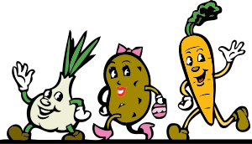
55. The sun helps covert carbon dioxide into a simple carbohydrate called:
56. What is another name for cellulose?
57. What does starch do for a plant?
58. When we break down glucose, what energy molecule is produced?
59. What are three ways we use ATP?
60. How is ATP like dollars?
61. Which organelle is responsible for breaking down carbohydrates into useable energy?
62. Do plants have mitochondria? Why?

ANAEROBIC & AEROBIC RESPIRATION
Use the link to watch the “Respiration” video. As you watch, fill in the blanks below.
http://tinyurl.com/jp52vct OR https://www.youtube.com/watch?v=Xp0o19gWX7E

63. What is the difference between respiration and breathing?
64. What is more efficient? - Anaerobic or Aerobic Respiration?
65. What compound is responsible for the cramps that we feel when we run out of oxygen?
66. The build up of lactic acid causes:
67. What is the name of the length of time needed for us to pay back our oxygen debt?

PHOTOSYNTHESIS & CELLULAR RESPIRATION
Use the link to play the Photosynthesis & Respiration Game by Bioman Bio. As you move through the game, answer the following questions. http://tinyurl.com/h47ql88 OR https://biomanbio.com/HTML5GamesandLabs/PhotoRespgames/photoresphtml5page.html

67. What molecule does the fruit represent?
68. The molecules you use in a chemical reaction are called the:
69. The molecules you produce in a chemical reaction are called the:
70. How many ATP molecules are produced in one reaction during cell respiration?
71. What are the reactants in respiration?
72. What are the reactants in photosynthesis?
73. What are the products in cellular respiration?
74. What are the products in photosynthesis?

ACTIVE & PASSIVE CELL TRANSPORT
Click on the following link to watch the “Cell Membrane and Cell Transport” video by the Amoeba Sisters. As you watch, answer the following questions. http://tinyurl.com/h47j98b OR https://www.youtube.com/watch?v=Ptmlvtei8hw

75. Keeping a stable environment inside cells is also known as keeping
76. The important cell organelle structure that controls what goes in and out of the cell is the
77. The cell membrane is made of a phospholipid . A bilayer means it has two layers of
78. Phospholipids have a head that is and a tail that is
79. What two gases easily diffuse through the phospholipid bilayer? and
80. In a concentration gradient molecules move from a concentration to an area of concentration.
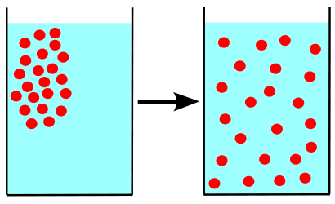
81. Stop the video at 3:51. Copy the information into the Venn Diagram below.
Simple Diffusion Facilitated Diffusion

82. Force against the concentration gradient flow from low to concentration takes because it is against the flow and typically requires energy.
83. ATP has phosphates and powers which forces molecules to go against the concentration gradient.
84. If a cell needs a large molecule, such as a polysaccharide, it must fuse with the cell membrane to bring it inside the cell in a process known as . “Endo” in the word endocytosis means
85. The three main type of endocytosis are , , and
86. The process that is the reverse direction of endocytosis when the cell moves material out of the cell is
87. Exocytosis helps the cell get rid of and moves out valuable materials the cell has made.

OSMOSIS
Use the link to access the Tonicity and Osmosis on Cells Virtual Lab from the Glencoe Science website. Follow the directions on this handout to complete the lab.
http://tinyurl.com/4d7pyl9 OR http://www.glencoe.com/sites/common_assets/science/virtual_labs/LS03/LS03.html

Place each cell in all three different liquids. In the chart below, record your results. Write “Shrink” if the cell shrinks, “Swell” if the cell swells, and “Normal” if the cell stays the same. In the last column, explain why this change or no change is occurring in your own words. Use the words water, solute, and concentration in all the answers to the fifth column.
Type of Solution | Red Blood Cell | Elodea Cell | Paramecium Cell | Where is the Water Going? Why?
88. Hypotonic Solution
89. Isotonic Solution
90. Hypertonic Solution

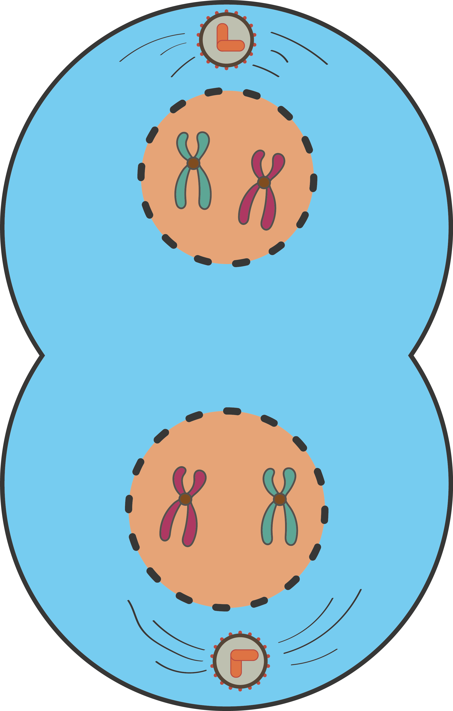

MITOSIS, THE CELL CYCLE, AND CANCER
Use the following link to watch the “Mitosis” video by the Amoeba Sisters. As you watch, answer the following questions.
http://tinyurl.com/hxaaae6 OR https://www.youtube.com/watch?annotation_id=annotation_3739956411&feature=iv&src_vid=gwcwSZIfKlM&v=f-ldPgEfAHI

91. Mitosis produces ONLY what type of cells?
92. Why is it important that during mitosis, your cells only make identical cells?
93 Do cells divide all the time? What is cancer?
94. In what phase of cell division to cells spend the most of their time?
95. What 3 things do cells do during interphase?
96. What percentage of time do cells spend in Interphase? What percent of time do they spend in mitosis?
97. What two things are chromosomes made of?
98. How many chromosomes do human body cells contain?

In the table below, draw what each phase of mitosis looks like. Be sure to draw the chromosomes, spindle fibers, and nuclear membrane in the appropriate phases.
Interphase | Prophase | Metaphase | Anaphase | Telophase | Cytokinesis
99. | 100. | 101. | 102. | 103. | 104.

MEIOSIS & GENETIC DIVERSITY
Use the link to complete the Snurfle Meiosis and Genetics 2 Game. Read the introduction to the game by clicking through the first two screens until you come to the main menu. Click on the “Crossing Over” tab. Fill in the blanks as you move through this activity. http://tinyurl.com/zkc9hno OR https://biomanbio.com/HTML5GamesandLabs/Genegames/snurflemeiosis2diversityhtml5page.html

Crossing Over!
105. At the start of meiosis you have cell. At the end of Meiosis I, you have . At the end of Meiosis II, you have
106. If there is no crossing over, the gametes are identical. What is true about such a cell that does not cross over during meiosis?
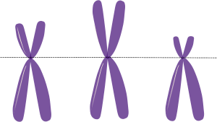
107. Remember, the letters shown represent alleles for specific genes. G and g represent two different alleles for fur color. B and b represent two different alleles for the butterfly wing trait.
G = B =
g = b =
108. Since the fur color and butterfly wing are the same and are inherited together, we say the genes are .
109. Crossing over occurs during of Meiosis I. Homologous chromosomes trade information.
110. What trades genetic information during crossing over?
111. More results because there is more in the possible due to
112. Recombination allows for more potential of offspring.

Independent assortment - Return to the Main Menu. Click on the “Independent Assortment” tab. Fill in the blanks and answer the questions below as you move through this section of the game.

113. Independent assortment also produces of gametes during meiosis. Independent assortment refers to how the chromosomes during Metaphase and Metaphase .
114. The homologous chromosomes are the size and have the same .
115. During Metaphase I of Meiosis I, these homologous pairs of chromosomes can line up in several ways. This is known as
116. The way that one pair of chromosomes line up does affect the way that any other pair .
Each pair lines up , hence the name independent assortment.
118. Independent assortment can also happen in cells during meiosis II, specifically during
119. Independent assortment produces many possible genetic in the gametes produced by an individual. This genetic in produces genetic in the population.

INHERITANCE & GENETICS

Use the following link to watch the “Incomplete Dominance Codominance” video by the Amoeba Sisters. After you watch, answer the following questions. http://tinyurl.com/hmb4a67 OR https://www.youtube.com/watch?v=YJHGfbW55l0

120. How are non-Mendelian traits rule breakers?
121. Explain the difference between incomplete dominance and codominance.
122. In chickens, the gene for feather color is controlled by codominance. The allele for black is B, and the allele for white is W. The heterozygous phenotype is black and white speckled.
What is the genotype for a black chicken?
What is the genotype for a white chicken?
What is the genotype for a speckled chicken?
123. Complete a Punnett square showing the cross between a speckled chicken and white chicken.
What percent of offspring is white?
What percent of offspring is black?
What percent of offspring is speckled?
124. A homozygous black bird is crossed with a homozygous white bird. The offspring are all gray. Complete a Punnett square showing this cross.
Is this an example of incomplete dominance or codominance?

DNA, RNA, & PROTEIN SYNTHESIS
Use the following link to access the DNA-The Double Helix Game from the Nobel Prize.org website. Fill in the question blanks and table as you go. http://tinyurl.com/jnxq54g OR https://educationalgames.nobelprize.org/educational/medicine/dna_double_helix/dnahelix.html

125. Most organisms have the same sort of in their cells.
126. The shape of DNA is called a .
127. The back bone or intertwining strands are made up of and . The rungs are , made up of different represented by the letters :
128. The base pair on a DNA molecule are connected by hydrogen bonds. The bases always pair up the same way. Adenine (A) pairs with , and Cytosine (C) pairs with .
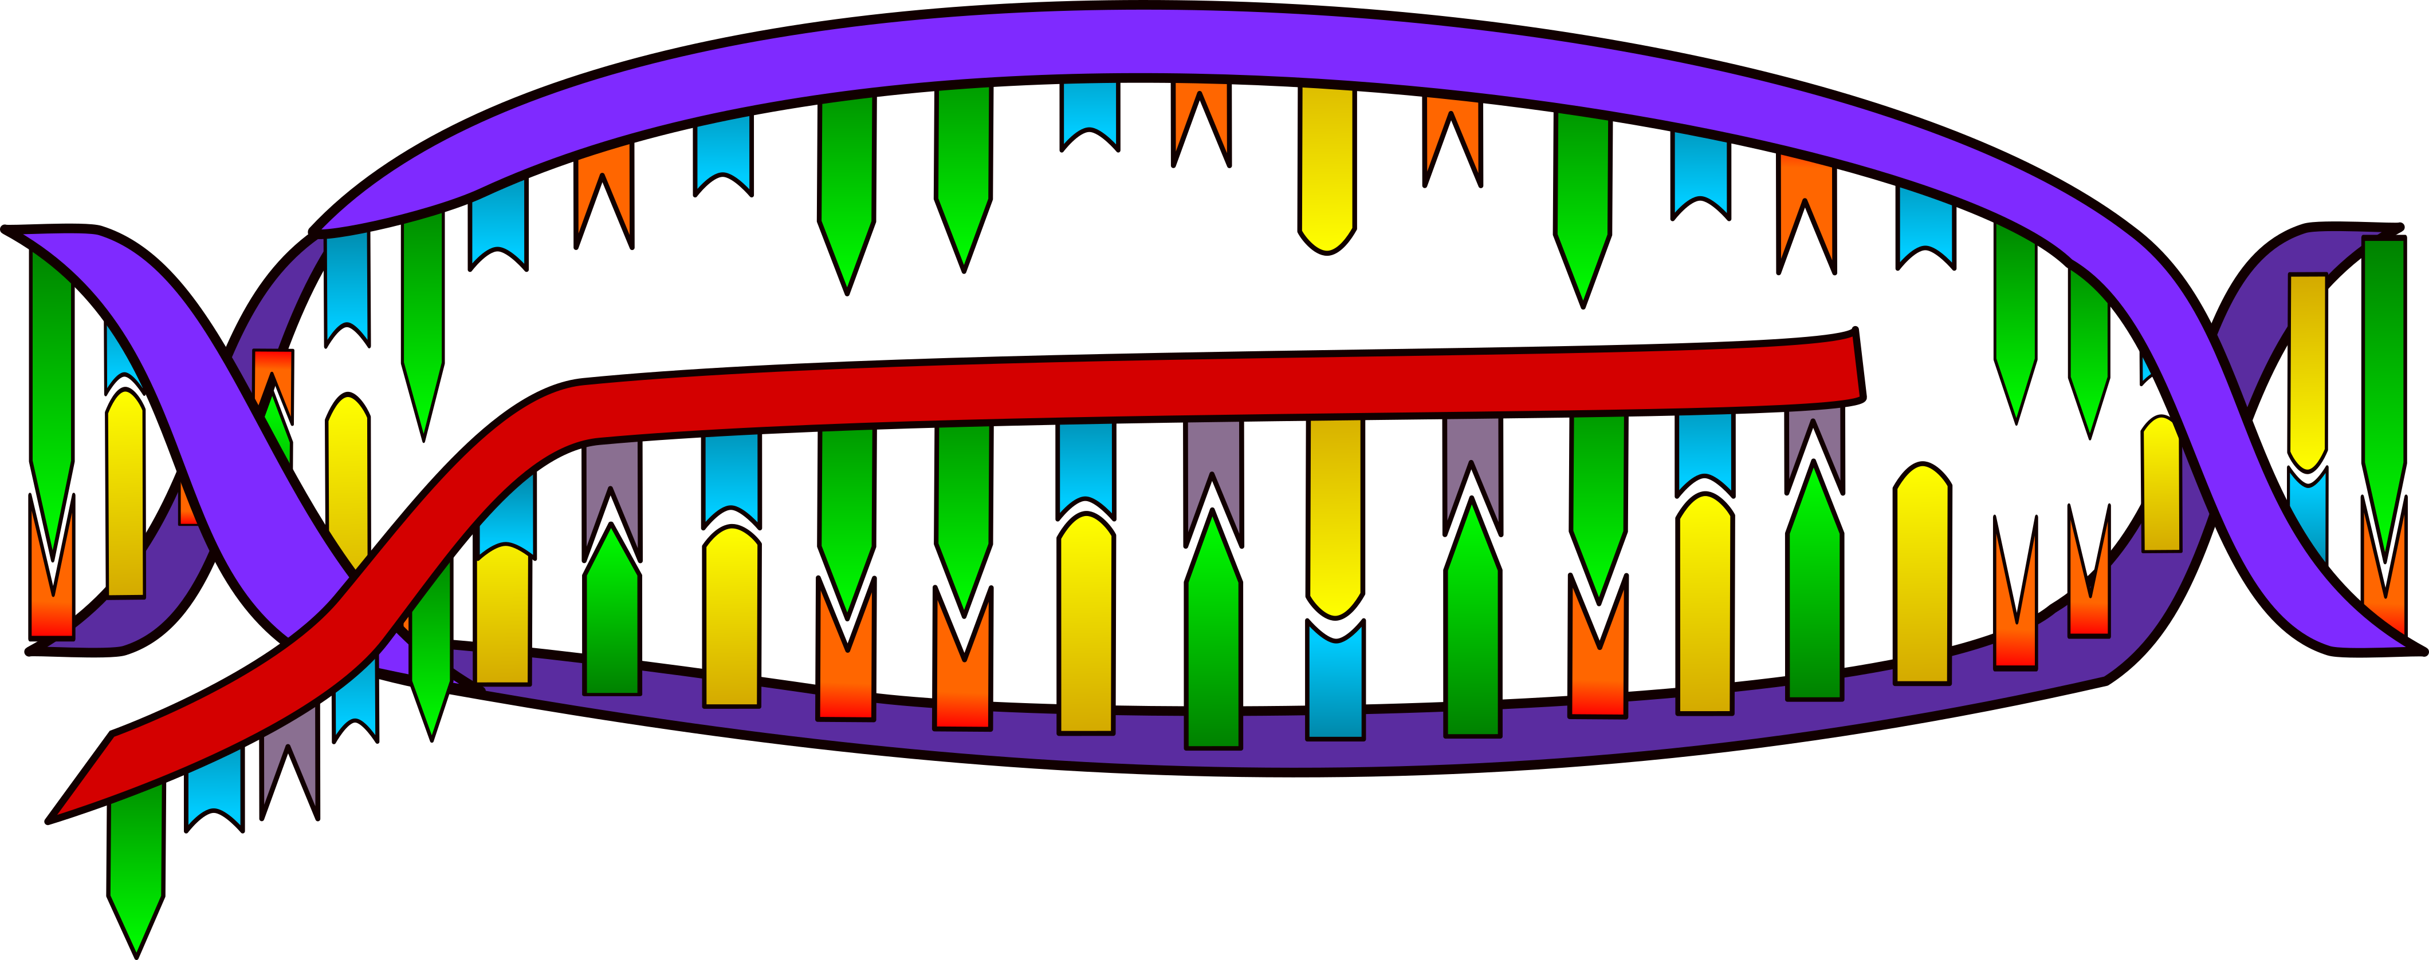
DNA Replication Data Table
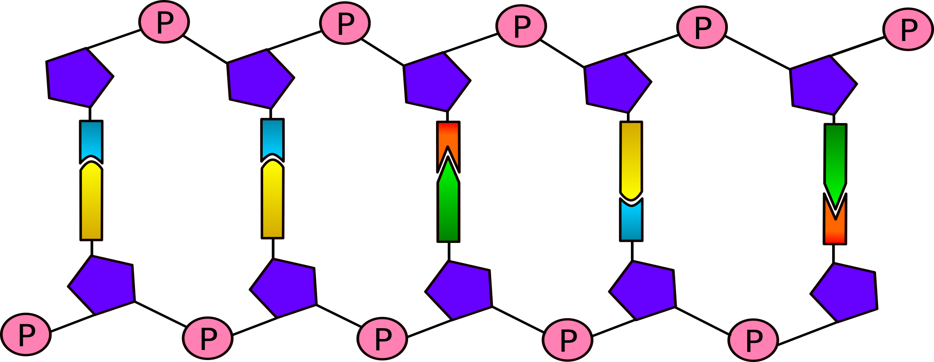 | Organism 1 | Organism 2 | Organism 3
# of genes
# of chromosomes
# of base pairs (millions)
# of mutations
(it’s supposed to have)
Name of organism
Total Points

Use the link below to play the Protein Synthesis Race Video Game from the BioMan Biology Website. Click “Start a New Game” to begin. Read the screens and follow the directions to complete the game. As you complete the game, answer the following questions on the handout. http://tinyurl.com/ccgfrky OR
https://biomanbio.com/HTML5GamesandLabs/LifeChemgames/protsynthracehtml5page.html

Transcription In the Nucleus
129. Transcription is the process of copying a gene to create
130. Transcription is the first process that must happen in order to make a
131. In order for transcription to happen, DNA must
132. How many strands of DNA are used for transcription?
133. Will you be playing with the top or bottom strip of DNA?
134. What is the name of the enzyme used to make RNA nucleotides?
135. What type of molecule did you create when you transcribed all of the nucleotides?
136. What does the messenger RNA (mRNA) do?
137. What happens to the DNA molecule after transcription?
138. Where does the messenger RNA have to travel to after transcription?
Transcription - Did You Get It? Answer the 9 multiple choice questions in the game. Write down your score here

Translation in the Ribosome
139. A protein is a chain of
140. The of amino acids in the chain and the of the chain determine what kind of protein it will be.
141. Codons are triplets of nitrogenous bases on mRNA that code for a specific
**Hint! Look at the chart at the upper right of the screen to see what codons code for which amino acid! Pick up the complementary tRNA anticodon to pair with the mRNA codon. When you are pairing the two codons, look at the mRNA code to pair with the correct amino acid color. Use the black line above the tRNA to pick up the correct color. Each code for amino acids is a specific color!
142. Which type of RNA is responsible for translation of mRNA?
143. What is another name of a chain of amino acids?
144. What happens to the ribosome after translation?
145. What does the shape of a folded polypeptide indicate?
Translation - Did You Get It?
Click on the correct term where the arrow or bracket is indicating. How many did you get correct?
Answer the 8 multiple-choice questions. Write your score here:

MUTATIONS
Use the following link to watch the “Mutations” video by Bozeman Science. Answer the questions below as you watch the video. http://tinyurl.com/h9qebqx OR https://www.youtube.com/watch?v=eDbK0cxKKsk

147. What are some causes of mutations?

Fill in notes in the following table as you learn about each type of mutation.
Topic | Notes
148. Point Mutation
149. Substitution
150. Insertion
151. Deletion
152. Frameshift Mutation
153. Duplication
154. Translocation
155. Inversion

ORIGIN OF LIFE – ENDOSYMBIOTIC THEORY
Use the following link to watch the “How We Think Complex Cells Evolved” video by TedEd. Answer the questions below as you watch the video. http://tinyurl.com/h3qq8u7 OR https://www.youtube.com/watch?v=9i7kAt97XYU

156. What type of organisms do scientists think were on Earth 2 billion years ago?
157. What is the process of cells living together called?
158. List three pieces of evidence that support endosymbiotic theory. 1)
2) ; 3)

EVOLUTION & NATURAL SELECTION
Use the following link to watch the “What Is Evolution” video by Stated Clearly. Answer the questions below as you watch the video. http://tinyurl.com/otcubhy OR https://www.youtube.com/watch?v=GhHOjC4oxh8
159. What is evolution?
160. How do DNA mutations influence evolution?
161. What ancestor did all modern dogs evolve from?
162. What is responsible for all the biodiversity that we see today?
163. According to Darwin and Wallace, what is another force capable of driving evolution?

Use the following link to complete Charles Darwin’s Game of Survival from the Discovery Science™. Follow the directions and answer the questions below as you complete the activity. http://tinyurl.com/yce3ouq2 OR
https://www.ologames.com/Free_Games/Who-Wants-To-Live-A-Million-Years
Click “Learn About Natural Selection” at the top of the screen.
Hover your mouse over the terms species and variations to show their definitions. Fill in the blanks below.

164. Species: The basic classification in biology that describes a of that resemble one another and are able to among themselves.
165. Variations: A in a characteristic or trait from one organism in a to another organism in the species.
166. Read what Darwin is saying from the bottom of the screen to answer the questions below:
- Are all members between a species exactly the same?
- What are some variations that individuals within a species may have?

Click “Go To Next Page” and breed the birds. Then click “Go To Next Page”
Hover your mouse over the term survival of the fittest to show the definition. Fill in the blanks below.
167. Survival of the Fittest: A summation of a theory of evolutionary processes that enable organisms that are for their to .
168. If an organism is born with traits that help it survive or attract mates, will it produce more or less offspring than a rival without those traits?
169. Eventually, beneficial traits will do what within a species?

Click on the “Survival Game” tab on the top of the game.

170. Darwin says that the traits you use will affect your species rate of survival depending on your environment. What can diversity ensure?

Look at the variations box to the upper left. Click through the different mutations by clicking on “more mutations”. Observe the variations of the species. Click on the “Hints” book in the bottom right hand corner to learn how to WIN!

Choose three different variations of adaptations to start the game. PLAY UNTIL YOU LIVE 1 MILLION YEARS!

171. What changing environments did you encounter?
172. Did you use any life rafts? If so, what did you change your mutation to in order to increase survival?
173. Pretend you have to tell a friend how to beat the game really quickly. What two mutations would you recommend for a hot environment and why?
174. Click on the “Quiz” tab on top of the screen to take the quiz. Write your final score here

PHYLOGENY & THE TREE OF LIFE
Use the following link to complete the “Evolution Lab” by PBS Nova. Answer the questions below as you complete the lab.
http://tinyurl.com/qj2flyl OR https://www.pbs.org/wgbh/nova/labs/lab/evolution/research#/chooser
175. Click on “Mission One Training Trees.” Watch the video to learn how to complete the lab. Write three things you learned in the video in the space below.
a)
b)
c)
Complete All Three Parts of The Training Trees Lab
176. Part 1: Red, Green, and Gecko
a) What trait does a gecko, fungus, and palm tree share?
b) Is an animal or plant more closely related to a fungus?
177. Part 2: Familiar Faces
a) What are amniotes? Which organism(s) is/are not amniotes?
b) What trait does all these organisms have in common?
178. Part 3: Tree of Life Vegetarian Edition
a) Is a banana more closely related to a lemon or an onion?

TAXONOMY & DICHOTOMOUS KEYS
Use the following link to watch the “What is Taxonomy” video by MonkeySee. Then answer the questions below.
http://tinyurl.com/zmu9lym OR https://www.youtube.com/watch?v=aiC_Z8Za7wc

179. What is taxonomy?
180. What system is used for assigning a scientific name to an organism?

181. What are the 5 Kingdoms of Life? 1. 2.
3. 4. 5.
182. What 2 taxonomic groups are used to make up a scientific name?
183. What are the 3 domains of life? 1. 2. 3.
184. What do we analyze today to classify organisms?

Use the following link to complete the “Classifying Life” interactive from Nova.
http://tinyurl.com/27e9q52 OR https://www.pbs.org/wgbh/nova/nature/classifying-life.html
185. List the Genus and Species for each of the following animals:
a) Bear:
b) Orchid:
c) Sea Cucumber:

Use the following link to watch the “Dichotomous Key” video by Mark Drollinger. Then, answer the question below.
http://tinyurl.com/kxzjbax OR https://www.youtube.com/watch?v=M51AKJqx-7s
186. Write out step-by-step directions for using a dichotomous key in the space below.

Use the following link to complete the Dichotomous Key for Bugs interactive. Then, answer the questions below. This is Flash-Based, therefore Firefox or Safari are recommended browsers for this interactive.
http://tinyurl.com/ndn4zs7 OR http://www.execulink.com/~ekimmel/dichotomous_bugs.swf
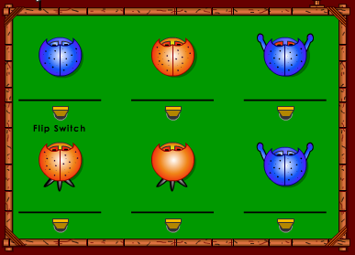
Use the Dichotomous Key in the interactive to identify the names of
3
2
1
each bug. Use the graphic to the right for the bug numbers.

187. What is the name of Bug #1?
188. What is the name of Bug #2?
189. What is the name of Bug #3?
6
5
4
190. What is the name of Bug #4?
191. What is the name of Bug #5?
192. What is the name of Bug #6?

HUMAN BODY SYSTEMS & REPRODUCTION
Use the following link to watch the “Human Body Systems” video by the Amoeba Sisters. Then, identify which body system that best fits each description below. Write that system on the line provided next to the description.
http://tinyurl.com/gtdklxw OR https://www.youtube.com/watch?v=gEUu-A2wfSE

193. Coordinates and controls all voluntary and involuntary actions.
194. Support the body, protect organs, and makes blood cells.
195. Breaks down and absorbs nutrients.
196. Provides ability to reproduce.
197. Intakes oxygen and releases carbon dioxide.
198. Keeps the body safe against pathogens.
199. Excretes waste, such as urine.
200. Exchanges gases and transports nutrients.
201. Secretes hormones.
202. Largest and most protective organ system.
203. Includes skeletal, smooth, and cardiac tissues.

Use the following link to watch the “The Reproductive System” video by Bozeman Science. Then, answer the question below. http://tinyurl.com/llatzvd OR https://www.youtube.com/watch?v=QSN5gfbzgwc

204. What type of reproduction produces clones?
205. Where are sperm created in the male reproductive system?
206. Where in the reproductive system is the egg fertilized?
208. What occurs to the uterine lining during the month?
209. What is a blastula and what does it develop into?

To the Google! Do a safe Internet search to research each of the three trimesters of human pregnancy. Describe what occurs in each stage in the table below.

Trimester | Weeks Spent In This Trimester | Describe the Development of the Human in This Trimester.
210.
First Trimester
211.
Second Trimester
212.
Third Trimester

BIOGEOCHEMICAL CYCLES
Click on the link to watch the “Biogeochemical Cycling” video by Bozeman Science. Then, answer the following questions. http://tinyurl.com/q682z4o OR http://www.bozemanscience.com/biogeochemical-cycling

213. What elements cycle between living and non-living organisms?
214. What is a mnemonic device to help you to remember the elements that life needs to survive?
215. True or False: Nutrients are recycled again and again in the biogeochemical cycles.

Complete the table below about how each element is stored and cycled between living and non-living things.
 | 216. Water | 217. Carbon | 218. Nitrogen | 219. Phosphorus
Where is it stored?
How does it get into animals?

How does it get into plants?

How does it get recycled again?

ECOLOGICAL SUCCESSION
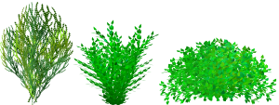
Use the following link to complete the Ecological Succession Interactive by BiomanBio. Answer the questions below as you interact with the simulation. https://tinyurl.com/yc42zszl
OR https://biomanbio.com/HTML5GamesandLabs/EcoGames/succession_interactive.html

Click on Start a New Game. Then click the Primary Succession Tab. Press Continue to move through the activity.
220. Describe the features of the volcanic island after it cools.
221. The changes in species composition in an area over time is called what?
222. When succession happens in a place with no life or soil, is it primary or secondary succession?

Click on Return to Main Menu and then click on the Secondary Succession tab.
223. What triggers secondary succession on the island?
224. What is the process of rebuilding a community that is disrupted called?
225. Why can your pioneer species be different in secondary succession?
226. Why can flowers rapidly germinate?
227. Why do bushes populate the island after grasses and flowering plants?
228. Why are tree seeds already on the island?
229. What is secondary succession?
BIODIVERSITY AND BIOMAGNIFICATION
Use the link the below to play the “Eco-Detectives: The Peril River Problem” video game from the BioMan Biology website. Click “Start a New Game” to begin. Read the screens and follow the directions to complete the game. As you complete the game, list 5 facts you learned in the space below. http://tinyurl.com/jc4yn4s
OR https://biomanbio.com/HTML5GamesandLabs/EcoGames/ecodetectiveshtml5page.html

230. Fact 1:
231. Fact 2:
232. Fact 3:
233. Fact 4:
234. Fact 5:

HUMAN IMPACT ON THE ENVIRONMENT
Use the link below to watch the Human Population Impacts video from Bozeman Science. As you watch, answer the questions.
http://tinyurl.com/h5ojwdd
OR https://www.youtube.com/watch?v=Z1haK55QKJ8&list=PLllVwaZQkS2qK4Z6xBVDRak8an1-kqsgm&index=15

235. Which hemisphere of the Earth releases the most Carbon dioxide into the atmosphere? Why?
236. What happens to Carbon dioxide (CO₂) levels in the Summer months? Why?
237. What happens to Carbon dioxide (CO₂) levels in the Winter months? Why?
238. What is an ecological footprint?
239. What does the I, P, A, and T stand for in the equation I = PAT?
240. The bigger the population is the (larger/smaller) the environmental impact.
241. Although Burundi and U.A.E. have the same population of 9 million, why does Burundi have a smaller ecological impact?
242. As countries develop, do they have more or less of an impact on the planet? Explain.
243. What is biocapacity?
244. What does the line at 2.0 on the graph represent?
245. In worldmapper.org, where is the highest level of poverty, population, and hunger in the world?
246. Look at the US for income and resource use. Did the US grow larger or smaller in size? How do you think this impacts the environment? .
247. If the economy is too big, does it have a negative or positive effect on the environment?

FOOD CHAINS & WEBS
Click on the following link to watch the “Food Webs and Energy” video by the Amoeba Sisters. Answer the following questions as you watch the movie. http://tinyurl.com/okmbkx8 OR https://www.youtube.com/watch?v=-oVavgmveyY
248. Why do the arrows in a food chain point to the organism doing the eating?
249. What trophic level contains the most amount of energy?
250. What is the energy lost between trophic levels go?
251. What percentage of energy is gained as you move up trophic levels?
252. What is the difference between a food chain and food web?
253. How does biodiversity contribute to the sustainability of an ecosystem?

254. Click on the following link to play the “Food Chain Game” on the Kids Corner website. After you play the game, draw last food chain you created in the space below. http://tinyurl.com/2h5gf6
OR http://www.sheppardsoftware.com/content/animals/kidscorner/games/foodchaingame.htm

BONUS: BIO STUDY RESOURCES & TIPS

This page includes many resources to help you practice for your end of course biology exam. They include links to videos and activities about the Bio EOC, and general tips for studying for exams.

Videos
Have a piece of paper and a pen ready to take notes during these videos. Write down facts you learn and topics you need to study more about.

1. 10 Things Not to Forget for the Biology EOC - by Mary Marshall (6:08)
http://tinyurl.com/gohy98z

2. 10 MORE Things Not to Forget for the Biology EOC - by Mary Marshall (4:01)
http://tinyurl.com/koqpgs4

3. Biology 2016 Final Exam Review – by Samantha Bean (19:34)
http://tinyurl.com/n2fakav

Practice Activities
Use these practice activities to practice your skills. Have paper and a pen ready to jot down anything you didn’t know and need to study more.

1. Varsity Tutors: Free Diagnostic Biology Exam Review (helps you identify what your strengths and weaknesses are in regards to your knowledge of biology content).
http://tinyurl.com/l52l2uu

2. Biology Course Review Quizlet Games and Flashcards: http://tinyurl.com/lkely5t

GENERAL EXAM TAKING TIPS
Use these tips to help you get the most out of your study sessions.

1. Video: The 9 Best Scientific Study Tips – by ASAP Science (3:25)
http://tinyurl.com/qjce85t

2. Video: 5 Rules (and One Secret Weapon) for Acing Multiple Choice Tests –
by Thomas Frank (9:42) http://tinyurl.com/kxjehgp

